Xpress Quality Manual
Life Cycle Activities Assignment

UNIT 7
SOFTWARE QUALITY MANAGEMENT

Submission Date: 5th September 2011

Submitted To: Suchita

Submitted By:

Class | MTECH SE18 (Saturday)
Team | 08S
Team Members
Feng Yan |  | A0065905
Hnin Nu Aye |  | A0005937
Jiang Jifa |  | A0065734
Liu Peishan |  | A0065963
Phung Kim Cuong |  | A0065998
Thida Khin Myo Thaung |  | A0005954
Zaw Htet |  | A0065880

Table of Contents
1 INTRODUCTION 3
2 MANAGEMENT RESPONSIBILITY 3
3 QUALITY SYSTEM FRAMEWORK 3
4 QUALITY SYSTEM FOR LIFE CYCLE ACTIVITIES 3
4.1 Introduction 3
4.2 Pre-Contract 4
4.2.1 Purpose 4
4.2.2 Process Flow 4
4.2.3 Quality Records 5
4.3 Contract Review 6
4.3.1 Purpose 6
4.3.2 Process Flow 6
4.3.3 Quality Records 7
4.4 Project Initiation and Planning 8
4.4.1 Purpose 8
4.4.2 Process Flow 8
4.4.3 Quality Records 10
4.5 Requirements Control 11
4.5.1 Purpose 11
4.5.2 Process Flow 11
4.5.3 Quality Records 12
4.6 Design Control 13
4.6.1 Purpose 13
4.6.2 Process Flow 13
4.6.3 Quality Records 15
4.7 Programming and User Documentation Control 16
4.7.1 Purpose 16
4.7.2 Process Flow 16
4.7.3 Quality Records 17
4.8 Testing and Validation 18
4.8.1 Purpose 18
4.8.2 Process Flow 18
4.8.3 Quality Records 20
4.9 Acceptance 21
4.9.1 Purpose 22
4.9.2 Process Flow 22
4.9.3 Quality Records 23
4.10 Delivery and Installation 24
4.10.1 Purpose 25
4.10.2 Process Flow 25
4.10.3 Quality Records 28
4.11 Maintenance 29
4.11.1 Purpose 29
4.11.2 Process Flow 29
4.11.3 Quality Records 32
5 QUALITY SYSTEM FOR SUPPORTING ACTIVITIES 32
APPENDIX A: CROSS-REFERENCES TO ISO STANDARDS 32
APPENDIX B: LIST OF PROCEDURES 32
APPENDIX C: LIST OF GUIDELINES 32
APPENDIX D: LIST OF FORMS 32

INTRODUCTION

MANAGEMENT RESPONSIBILITY

QUALITY SYSTEM FRAMEWORK

QUALITY SYSTEM FOR LIFE CYCLE ACTIVITIES

Introduction
The main business of Xpress Systems Pte Ltd is to undertake software contracts for customers. These contracts can be either new development, enhancement of existing systems, or partial developments of part of some life cycle. From the point view of the QMS, all projects are treated the same – they all involve delivering the requirements specified by the customer.

In Xpress Pte Ltd, there are totally eleven life cycle activities during a software project, listed as following:
- Pre-Contract
- Contract Review
- Project Initiation and Planning
- Requirements
- Design
- Programming and User Documentation
- Testing and Validation
- Acceptance
- Delivery and Installation
- Maintenance

The QMS requires various control mechanism to be implemented throughout the life cycle in order to meet the quality requirements as well as functional requirements. In the next sections, we will describe the detail tasks and control of the activities.

Notes: in the diagrams in subsequent sections, the document reference short form is used for the ease of reading.

For e.g.:
In the diagram, QP.1 is equivalent to XPRESS/QMS/QP.1

Or QF.3 is equivalent to XPRESS/QMS/QF.3

Pre-Contract
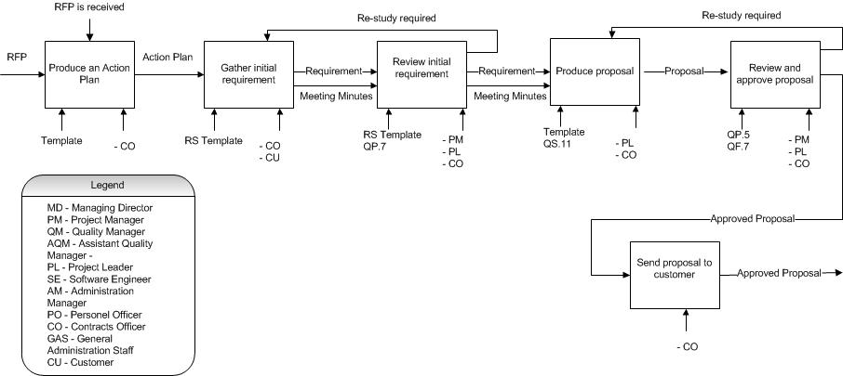

Purpose
- To ensure customer’s initial requirements are captured and properly processed
- To ensure customer requirements are met with the aim of enhancing customer satisfaction
- To ensure high possibilities to win business opportunities

Process Flow
Steps | Tools/References
- Develop an action plan for the pre-contract activity
  - Plan the tasks for this activity to win opportunity

- Gather the initial requirements
- If the request for proposal (RFP) is received, study the RFP to get the initial requirements. Request for additional information from the customer if necessary
- If the request is by informal means, get the initial requirement from the customer. Get the customer’s confirmation on the documented initial requirements if possible

- Review the initial requirement  - Identify the additional requirements not specified by the customer  - Identify any risks that must be overcome  - Identify Xpress’s strengths and weakness to address opportunity | XPRESS/QMS/QP.7
- Does the company have the ability to do it?
- The criteria to evaluate include:
    - Technically feasibility
    - Timescale feasibility
    - Financially feasibility
- If all of the above criteria are satisfied, proceed to step 5

- Produce the proposal  - Propose a solution to meet the entire requirement, the proposal should address the customers’ needs and how Xpress proposes to meet their needs.  - If the proposal uncovers any weaknesses, try to revise it. Conduct another review meeting for this if necessary. | XPRESS/QMS/QS.11
- Review and approve proposal  - The review criteria include:  - Proposal feasibility in both business and technical terms;  - Whether XPress Systems has the necessary facilities, abilities and technical skills to meet the requirements  - If any of the above criteria is not satisfied, the proposal needs to be either revised or postponed  - If proposal is approved, record it formally on the Approval Record Form | XPRESS/QMS/QP.5  XPRESS/QMS/QF.7
- Is proposal approved?
- If the proposal is not approved, proceed to restudy the original proposal. Otherwise, proceed to step 8

- Send proposal to customer
- Send the approved proposal to the customer
- Xpress should communicate with customer to follow up the status of the proposal.

Quality Records
- Proposal approval form

Contract Review
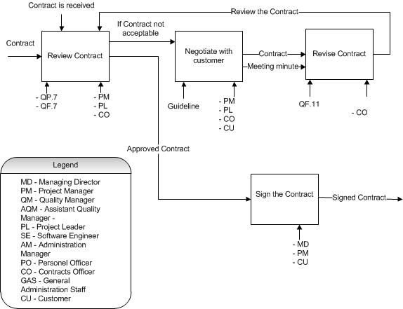

Purpose
- To ensure customer's requirements are adequately defined
- To ensure the company has the ability to meet the contract requirements.
- To ensure order requirement change can be managed
- To ensure the contract are technically feasible, feasible in terms of timescale and financially viable

Process Flow
Steps | Tools/References
- Review Contract  - Review criteria are in terms of:  - All the customer’s requirements are adequately defined and are well understood.  - The company has the ability to meet the contract requirements  - If the contract is awarded with a proposal, all the differences between the proposal and the contract are resolved.  - File the reviewed records | XPRESS/QMS/QP.7
- Is the contract acceptable?  - If any of the above criteria is not satisfied, the contract should not be accepted.  - If the contract is acceptable, proceed to step 5.  - If the contract is not acceptable, the amendments to it should be proposed to the customer | XPRESS/QMS/QF.7
- Negotiate with customer
- Negotiate with customer regarding the unsatisfied criteria and try to find a solution that can be accepted by both parties
- Record the communication with the customer

- Revise the contract  - Revise the contract based on the agreed solution  - Pass the contract to the other party for reviewing and signing | XPRESS/QMS/QS.11
- Sign the contract
- If all of the criteria are satisfied, sign the contract
- File the record to customer for reference

Quality Records
- Record of contract review
- Record of signed contract
- Record of customer communications on the contract

Project Initiation and Planning
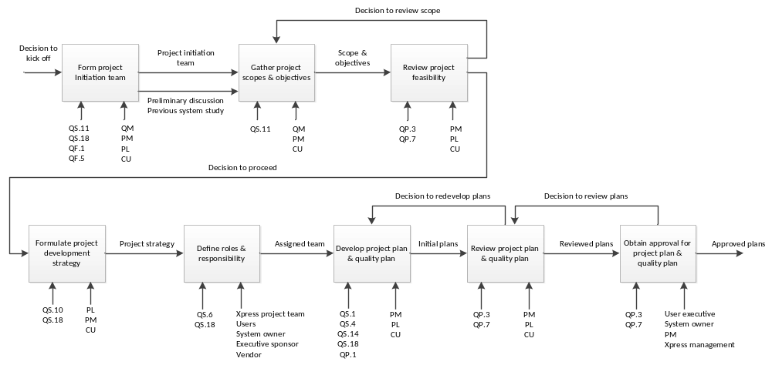

Purpose
- To confirm the objectives, the purpose and the scope of the project.
- To establish the project organization.
- To define the project planning.

Process Flow
Steps | Tools/References
- Form project initiation team  - This step is to form the team who is responsible for kicking off the project; usually it includes the project leader and the user project coordinator.  - It is essential that the user coordinators/ user representatives possess sound knowledge in their business domain | XPRESS/QMS/QS.11  XPRESS/QMS/QS.18  XPRESS/QMS/QF.1  XPRESS/QMS/QF.5
- Gather project scopes & objectives  - This step is to collect the scope and objectives of the project, this information can come from the business strategy of the customer or from previous system study.  - The agreement to this scopes and objective should be made by both management sides before evaluating the feasibility of the project | XPRESS/QMS/QS.11
- Review project feasibility  - This step is to evaluate the prospective of such system, taking into consideration the current situation and business requirements of the customer  - This step also validates and verifies that the implemented system will meet the purposes and objectives defined in the previous step.  - This step also estimates the risks and risk mitigation strategies that involved the project. The final decision is a jointly made decision by both sides: the customer and the vendor management.  - If the project feasibility study show that the project is overwhelming or not relevant, the project team probably need to go back and revise the scopes as well as the objectives, or choose to terminate the project. If terminated, the project ends here and the initiation team dissolves. | XPRESS/QMS/QP.3  XPRESS/QMS/QP.7
- Formulate project development strategy  - If the project scopes are feasible and accepted, the team will move on to define the high level development strategy (whether in-house /outsource, with waterfall / RUP / Agile methodology).  - The high level development phases require users to be extensively included. | XPRESS/QMS/QS.10  XPRESS/QMS/QS.18
- Define roles & responsibility  - This step is to formalize the project organization, to define the designation of the staff as well as the responsibilities for each related party.  - It is recommended that a project sponsor and system owner to be identified for the project] | XPRESS/QMS/QS.6  XPRESS/QMS/QS.18
- Develop project plan & quality plan  - This step is to define the project plan – the most important plan for the project which addresses almost all aspects during project duration.  - This step also defines the quality plan, which serves as the ultimate guide and reference to address quality-related matter during the project.  - The output of this step will need to be reviewed by both management from company and the user. | XPRESS/QMS/QS.1  XPRESS/QMS/QS.4  XPRESS/QMS/QS.14  XPRESS/QMS/QS.18  XPRESS/QMS/QP.1
- Review project plan & quality plan  - It is recommended to review the plans with user representative / coordinator before submitting to management for approval. The purpose of this step is to ensure the correctness and completeness of the plans.  - If rework required, the project team will have to go back and revise the plan, taking the feedback into consideration. | XPRESS/QMS/QP.3  XPRESS/QMS/QP.7
- Obtain approval for project plan & quality plan  - This step is to obtain the formal approval and sign-off from the management, which server as the legal supporting document to kick off the project.  - If the plans are not approved, the team will need to go back and review the plan again.  - If the plans are approved, the team proceeds with next steps with the signed plans. | XPRESS/QMS/QP.3  XPRESS/QMS/QP.7

Quality Records
- Project plan
- Quality plan
- Review forms

Requirements Control
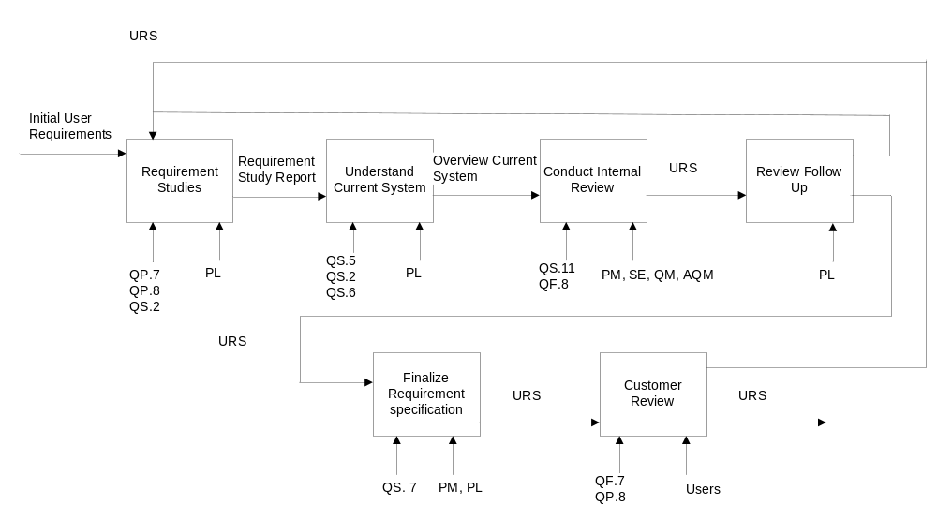

Purpose
- To ensure the documentation meets the requirements of customers.

Process Flow
Steps | Tools/References
- Requirement Studies  - The Project Leader meets the customer and gather requirements  - Project Leader analyzes the requirements  - Project Leader drafts the requirements specification based on the gathered requirements | XPRESS/QMS/QP.7  XPRESS/QMS/QP.8  XPRESS/QMS/QS.2
- Understand Current System  - Gather information on the current system. This can done using following means:  - Surveys  - Field observation  - JAD sessions  - Studying User Operation Procedures | XPRESS/QMS/QS.5  XPRESS/QMS/QS.2  XPRESS/QMS/QS.6
- Conduct Internal Reviews  - The Software Engineer, Quality Manager, Assistant Quality Manager, Project Manager does an internal review of the draft and baseline.  - A further review may be held with the user management to resolve issues that would require user management’s decision.  - Summaries and confirm the requirement, Review scope of requirement against scope in project plan. | XPRESS/QMS/QS. 11  XPRESS/QMS/QF.8
- Review Follow Up  - Based on the reviews, requirement may need to be re-specified due to the additional requirement or changes to requirement, Go back to step 1 to conduct requirements gathering session if necessary.  - Otherwise proceed to finalize the requirement | XPRESS/QMS/QS.4
- Finalized Requirement Specification  - Consolidate requirement gathered and complied the final requirements specification in accordance with template  - Review the finalized user requirement specification with the user project coordinator(s) before presenting to user management for approval | XPRESS/QMS/QS.7
- Customer Review  - Project Leader submits the base lined document for external review to the customer.  - On Acceptance by the customer, the approval from recorded formally and attached the completed form to the requirement specification. And inform all the users who participated in the reviews on the finalized requirement.  - The User requirement Specification that is approved by the customer must be versioned.  - Non acceptance or approved, re-study the requirement from the step 1 | XPRESS/QMS/QF.7  XPRESS/QMS/QP.8

Quality Records
- Review Records
- User Requirement Specification
- User Requirement Specification Approval Form

Design Control
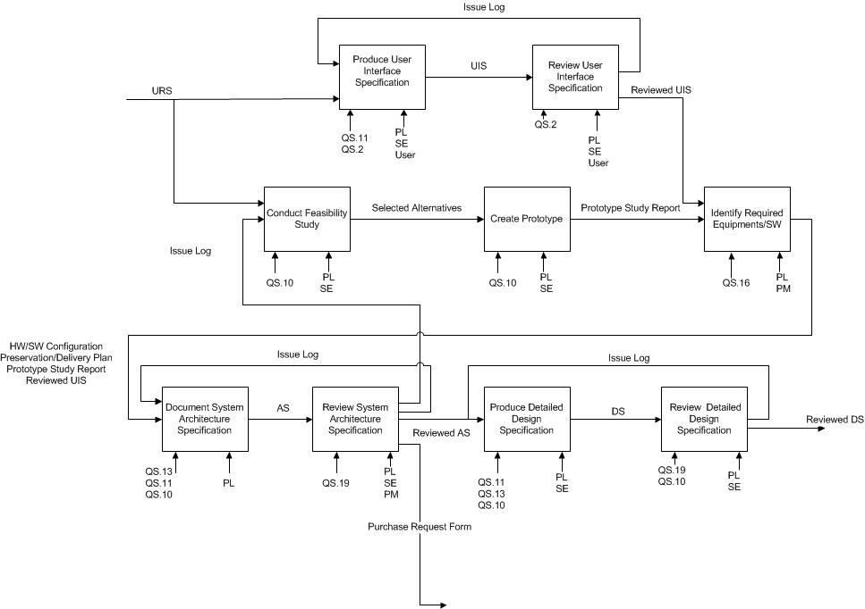

Purpose
- To establish mechanism to transform requirements into code.

Process Flow
Steps | Tools/References
- Conduct Feasibility Studies
- If the development strategy specified in Project Plan is applicable and there is no new development or emergence of new and better technical alternatives, proceed to step 3. Otherwise, continue with the following activities:
- Review the development strategy, consider various technical designs and propose alternatives to meet the user requirement. Assess the engineering team’s capability and consider alternatives such as outsourcing.

- Create Prototype
- Prototype the alternatives and highlight advantages and disadvantages for each alternative
- Evaluate alternatives based on how well each one of them achieve system objectives, impact of the system, risks involved , cost incurred and benefit derived
- Based on evaluation, select the best alternative with justification stated.
- Produce an prototyping study report which will provide the input for step 3 and step 6

- Produce User Interface Specification  - Gather all the user interface related information from the Requirement Specification, user story and meeting minutes  - Determine appropriate design tools to be used. Consider joint design with user through meeting/discussion/walkthroughs  - Prepare draft layout and description for the screens, reports and other input/output documents. | XPRESS/QMS/QP.9  XPRESS/QMS/QS.11  XPRESS/QMS/QS.2
- Review User Interface Specification  - Conduct a review with technical staff and management to check the recommended technical solution. Obtain management approval and if necessary, user management on the recommended solution  - If the recommended solution is not approved, go back to step 3 | XPRESS/QMS/QP.7  XPRESS/QMS/QS.2
- Identify Required Equipment / Software  - Identify the type of equipment required to implement the system. Assess the feasibility of using existing equipment if any. This will form inputs to tender specifications for new/additional equipment  - For systems to be developed using customer supplied equipment, create reservation/delivery plan | XPRESS/QMS/QS.16
- Produce System Architecture Specification  - Consolidate design from previous steps and compile the System Architecture Specification in accordance with the template  - Confirm development platform an d naming conventions  - Confirm the packaging and interfaces with external system  - Establish the transition strategy | XPRESS/QMS/QS.10  XPRESS/QMS/QS.11  XPRESS/QMS/QS.13
- Review System Architecture Specification  - Ensure that the requirements in the Requirement specification are traceable to the content of System Architecture Specifications  - Walkthrough with users to verify that all requirements are correctly translated if necessary  - Log down the issues into the Issue Log.  If there are issues identified,  - Go back to Step 1 if the new feasibility studies is needed  - Otherwise, Go back to Step 6 to revise the document | XPRESS/QMS/QP.7  XPRESS/QMS/QS.19
- Produce Detailed Design Specification  - Decompose the to document their proposed implementation in accordance to the transition mechanism establish in Step 6  - Create database Entity/Relation Design | XPRESS/QMS/QS.10  XPRESS/QMS/QS.11  XPRESS/QMS/QS.13
- Review Detailed Design Specification  - Walkthrough the design at the review session.  - Record suggestions, decisions and relevant comments from the review session in the Issue Log  If there are issues identified,  - Go back to Step 8 to revise the document | XPRESS/QMS/QP.7

Quality Records
- System Architecture Specification
- Detailed Design Specification
- Purchase Request Form
- Record of review
- Preservation/Delivery Plan of Customer property

Programming and User Documentation Control

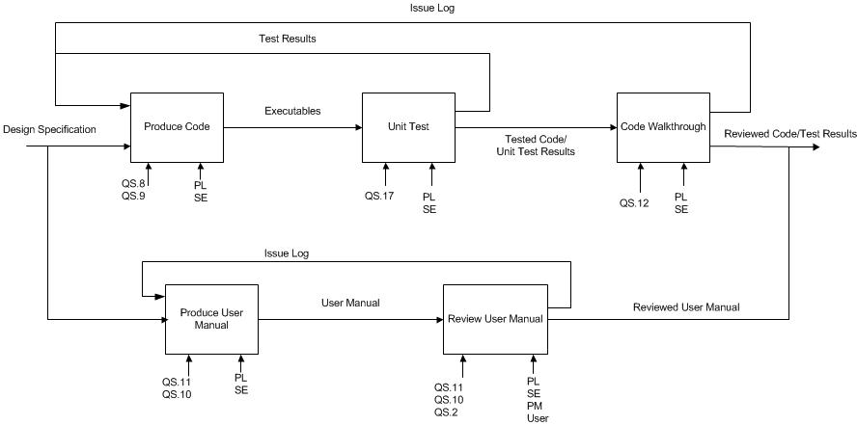

Purpose
- To produce consistent, maintainable code that implements the design specification.

Process Flow
Steps | Tools/References
- Produce Code  - To produce executable code, use a program shell containing the project standards and any existing reusable source code. The source code should conform to the detailed design specifications. Include the necessary comments on the source code at the same time  - Refer to Program Coding Standards and Guidelines sections of the Guide to programming Standards | XPRESS/QMS/QS.8  XPRESS/QMS/QS.9
- Unit Test  - Identify functional and structural test objectives according to the detailed design specification  - Define the test cases and data according to the test objectives  - Execute test cases and record the test results  - Revise code, test cases and data until all the errors are eliminated | XPRESS/QMS/QS.17
- Code Walkthrough  - Initiate a walkthrough or review to go through the source code and unit test results if necessary. The review may be for selective program, especially those that are critical or complex.  - Participants should examine the entire program, reviewing instruction usage, coding standards, documentation, efficiency and maintainability.  - Log down the issues into the Issue Log.  If there are issues identified,  - Go back to Step 1 to revise the code | XPRESS/QMS/QP.7  XPRESS/QMS/QS.12
- Produce User Manual  - The purpose of User Manual is to assist users to effectively operate and use the functions of the system. The User Manual should integrate the system functions with the manual operations and include any related operating policies or regulations.  - User’s involvement in the preparation of the manual should be encouraged | XPRESS/QMS/QS.10  XPRESS/QMS/QS.11
- Review User Manual  - Review the manual for completeness, correctness and clarity  If there are issues identified,  - Go back to Step 4 to revise the document | XPRESS/QMS/QP.7

Quality Records
- Code
- Unit Test Results
- User Manual
- Record of review

Testing and Validation
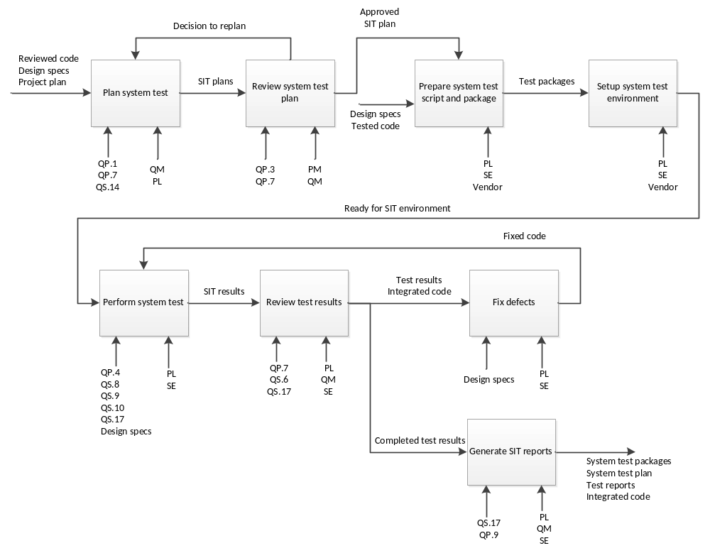

Purpose
- To ensure the developed system meet the design specifications.

Process Flow
Steps | Tools/References
- Plan system test.  - This step is to define the schedule and the milestone of the system integration test phase  - It will also define the scope of the testing: what function to be tested, what are the type and level of test.  - This plan need to focus on the design specifications and the macro level of business requirements, and should not overlap with what the unit test can deliver. The plan will also define the test strategy and approach to conduct system integration test.  - This plan will also highlight the role and responsibilities for all parties involved in this phase. Furthermore, it will also define the criteria to enter and exit system test as well as the resources needed. | XPRESS/QMS/QP.1  XPRESS/QMS/QP.7  XPRESS/QMS/QS.14
- Review system test plan  - This step is to formalize the agreement to proceed to system test, and obtain commitment to the resources required. If re-plan needed, the team will revert back to previous step to redefine the plan; Otherwise, the team will proceed to next step. | XPRESS/QMS/QP.3  XPRESS/QMS/QP.7
- Prepare system test script and package
- This step is to define the test cases / test scenarios / packages that address the design specifications.
- This step will also prepare any necessary test data, test condition and resource to support the integration test.

- Setup system test environment
- This step is to set up the test environment that going to be used for system test execution

- Perform system test  - This step is to execute the test scripts / test cases / test packages that were defined previously. All tests in this step required to have:  - Expected result  - Actual result  - Error/messages/logs that were recorded.  - The test result will be recorded for reviewing purpose. | XPRESS/QMS/QP.4  XPRESS/QMS/QS.8  XPRESS/QMS/QS.9  XPRESS/QMS/QS.1  XPRESS/QMS/QS.17  Design specs
- Review test results  - This step is to verify whether the system meet the design specification and the correctness of the test results. This step will provide an overview of the system quality, the correctness and completeness of all features, as well as the status of the test performed.  - If the system fulfills the design specifications and the exit criteria, the project team can proceed with next stage in the project.  - Otherwise, if defects are found or fixes are required, the team will need to proceed with fixing and re-test. | XPRESS/QMS/QP.7  XPRESS/QMS/QS.6  XPRESS/QMS/QS.17
- Fix defects  - This step is to identify the root causes, estimate the impact and to define a solution of any defect that is found during test execution.  - After fixing, the team needs to perform appropriate level of re-test and/or update the relevant documents that are impacted by the changes. | Design specs
- Generate SIT reports  - This step is to summarize the status and problem encountered during system test. It should highlight any concern and major problems that hampered the test process, and caused slippage or deviation of the plan.  - This is also to confirm whether the system test process is successful, and whether the project is meeting the exit criteria of this step. If so, the project team can proceed with the next stage (User Acceptance Test) | XPRESS/QMS/QS.17  XPRESS/QMS/QP.9

Quality Records
- System test packages
- System test plan
- System test reports

Acceptance
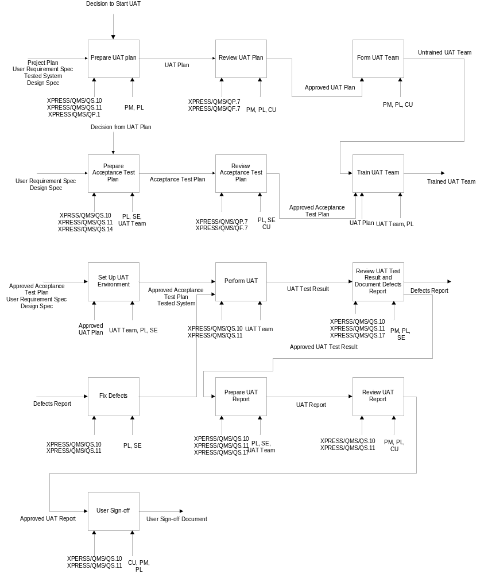

Purpose
- To get formal acceptance from the customer in order to deliver the product.

Process Flow
Steps | Tools/References
- Prepare UAT plan  - PM and PL will prepare UAT plan for the system which had already done for unit and system testing. | XPRESS/QMS/QS.10  XPRESS/QMS/QS.11  XPRESS/QMS/QP.1
- Review UAT plan  - After preparing UAT plan, PM, PL and Customer will review the UAT plan and approve to continue the process. | XPRESS/QMS/QP.7  XPRESS/QMS/QF.7
- Form UAT Team
  - Select UAT team members from Customers and project team.

- Prepare Acceptance Test Plan  - Acceptance Test Plan includes test scenarios and cases, is a simulation of live cases which will have to support by the system being tested. UAT team, PL and project team will prepare acceptance test plan. | XPRESS/QMS/QS.10  XPRESS/QMS/QS.11  XPRESS/QMS/QS.14
- Review Acceptance Test Plan  - PM, PL and Customers will work in this step jointly to review the Acceptance Test Plan. The purpose of this meeting is to check the feasibility and completeness of the Acceptance Test plan. The suitable review strategy should be introduced and the sign-off of the participant in the approval form is the exit condition of the review. Minutes of meeting and records of the review should be maintained. | XPRESS/QMS/QP.7  XPRESS/QMS/QF.7
- Train UAT Team  - The training will be conducted in this step based on UAT plan which already defines the content of the training and the participants. After this training, UAT team should understand the test plan of the product. | UAT Plan  Acceptance Test Plan
- Set up UAT Environment  - This step prepares and setup the UAT environment which will be used for UAT execution | UAT Plan
- Perform UAT  - This is actual execution of UAT scripts and test packages, the results of the test will be recorded for reviewing purpose. | XPRESS/QMS/QS.10  XPRESS/QMS/QS.11
- Review UAT Test Result and Document Defects Report  - This step reviews the test results to identify the root cause and perform analysis that can be used for fixing defects | XPRESS/QMS/QS.10  XPRESS/QMS/QS.11  XPRESS/QMS/QS.17
- Fix Defects  - The project team will identify the root cause, form the possible solution and make corresponding changes to the application. Related documentation will also need to be updated regarding to the changes made. | XPRESS/QMS/QS.10  XPRESS/QMS/QS.11
- Prepare UAT Report  - This step is to summarize the quality of the system after UAT, and give an overview about quality aspect of the project. The UAT report serves as a document to obtain customer approval and sign-off. | XPRESS/QMS/QS.10  XPRESS/QMS/QS.11  XPRESS/QMS/QS.17
- Review UAT Report  - This step is to ensure the correctness and completeness of UAT report before sending out to customer for final review and sign-off. | XPRESS/QMS/QS.10  XPRESS/QMS/QS.11
- User Sign-off  - In this step, user representative acknowledges and confirms that the system meet the requirements and is ready to be deployed into production. Any defect/ change to be made after this step will be considered as a change request. | XPRESS/QMS/QS.10  XPRESS/QMS/QS.11

Quality Records
- UAT plan
- Acceptance Test Plan
- UAT Report
- Defects Report
- Review Records for each activity
- User Acceptance Sign-off

Delivery and Installation
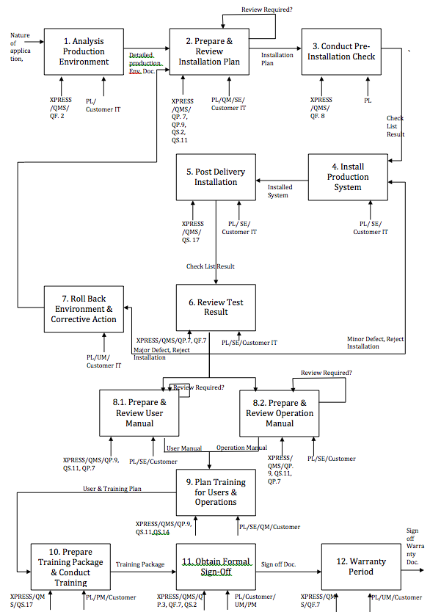

Purpose
- To install and deliver the accepted system to end user

Process Flow
Steps | Tools/References
- Analysis Production Environment
- The project leader should interact with the customer IT staff and perform inspection for the Production environment before preparing the installation plan.

- Prepare & Review Installation Plan  - The Project Leader should interact with the customer and prepare the deployment plan and installation instructions to make the system fully operational  - Highlight the scope of the installation plan, which includes what is required and what is not required to be implemented in this stage  - Plan the installation approach, giving details on the items to be installed, operating environment instructions on setting up the installation environment, installation steps.  - Include the relevant parties involved in installation to review the installation plan feasibility. The parties involved could be computer operations staff, technical support staffs. Check with users on whether any installation activities would affect existing operations. | XPRESS/QMS/QP.9  XPRESS/QMS/QS.11  XPRESS/QMS/QS.2  XPRESS/QMS/QP7
- Conduct Pre- installation Check  - Check that the software is approved and released for the user. This can be in the form of user acceptance sign-off.  - Check that all the prerequisite installation activities in the installation plan are carried out. This step also includes security clearance to access the user/customer office and computer system, if the installation is to be done at user’s site.  - Verify that all the programs, jobs and file names used are according to required naming standards for production environment.  - Check that the data is ready for loading if there is data conversion | XPRESS/QMS/QF.7
- Install Production System  - Carry out the installation and any data loading on the scheduled date and time, and in accordance with installation steps.  - If the installation is successfully completed, go to step 5. Otherwise, follow fallback procedures if necessary. Analyze cause of failure and rectify accordingly. | Installation Plan
- Post Delivery Installation  - Confirm completeness of the installation using a post installation checklist.  - Verify the accuracy, completeness and integrity of data loaded. | XPRESS/QMS/QS.17
- Review Test Result  - Review the post installation checklist result.  - If installation is not successful due to minor defect found, go back to step 4, make arrangement to schedule for re-installation. Update the installation Plan if necessary.  - If installation is not successful due to the major defect, go to step 7 to roll back Environment to the initial state and perform the corrective action. | XPRESS/QMS/QP.7  XPRESS/QMS/QF.7
- Roll Back Environment & Corrective Action
- It is important to validate if the system has adapted itself to the production environment. There might be some deviations from the production environment to the development environment; The Project Leader will analyze these deviations.
- The project leader and user manager will conduct the post-delivery validation tests. Customer’s IT team will be involved in this activity.
- The results of these tests will be reviewed and approved by Quality Manager and the User manager in the Customer side. The Software engineers of Xpress Systems Pvt. Ltd along with the PL will correct any non-critical defects.
- If there are any high severity defect or installation problems, the production environment is rolled back the original state. Unless mentioned in the contract, this roll back strategy is out of the scope of Xpress Pvt. Ltd., and is left to the customer side IT team. An analysis will be conducted by the PL and the User manager as to find and eliminate the root cause of the defect / problem before going for the next attempt.
- The installation plan should be prepared and reviewed again by project manager by going back step 2

- 8.1 Prepare & Review User Manual  - The purpose of user manual is to assist users to effectively operate and use the functions of the system. The User Manual should integrate the system functions with the manual operations and include any related operating policies or regulations. User’s involvement in the preparation of the manual should be encouraged.  - It is recommended that the manual be tested during User Acceptance Test. The manual should also be used as an input for training  - Review the manual for completeness, correctness and clarity. | XPRESS/QMS/QP.9  XPRESS/QMS/QS.11  XPRESS/QMS/QP.7
- 8.2 Prepare & Review Operations Manual  - The Operations Manual is used to provide information to Operations staff on how to support the operation of the system. Depending on the computer operations environment, information requirements may differ in contents and presentation format (i.e. forms). The Operations Manual template provided here is the minimum set of information required. Use this template and supplement with forms and other information required from the site’s computer operations unit.  - Involve operations staff in reviewing the manual for readability, completeness and compliance to standards.  - It is recommended that the Operations Manual be tested during the user acceptance test. | XPRESS/QMS/QP.9  XPRESS/QMS/QS.11  XPRESS/QMS/QP.7
- Plan Training for Users & Operations  - It is recommended that a training plan be prepared for projects, which involve extensive application training in terms of training scope and/or a large number of users.  - Involve users in the preparation of the training plan. Consider train-the-trainer approach for users to continue subsequent training for other new users  - It is recommended that the manual be tested during User Acceptance Test. The manual should also be used as an input for training  - Review the manual for completeness, correctness and clarity. | XPRESS/QMS/QP.9  XPRESS/QMS/QS.11  XPRESS/QMS/QS.14
- Prepare Training and Conduct Training  - Prepare necessary document to invite participants for the training and prepare required resource to conduct the training.  - Prepare training package using User Manual and /or Operations Manual as reference  - If training is extensive, review the training package for effectiveness  - Conduct training dry- run for new trainer(s) if necessary. | XPRESS/QMS/QS.17
- Obtain Formal Sign-off  - Obtain records on user sign-off on the system after successful implementation. These records could be in the form of minutes or memorandum.  - Establish the operational baseline which would be an input for maintenance | XPRESS/QMS/QP.3  XPRESS/QMS/QF.7 XPRESS/QMS/QS.2
- Warranty Phase  - The system is now said to be in warranty phase for the period specified in the contract agreement, generally this period does not exceed 3 months according the Xpress Systems  - Project Leader is responsible for setting up a ticket based system for the end users to log defects. These defects are to be fixed and re-tested as per the agreed SLA. | XPRESS/QMS/QF.7

Quality Records
- Installation Plan
- Record of Internal Reviews
- Test Result Documentation
- Approval Record Form Record

Maintenance
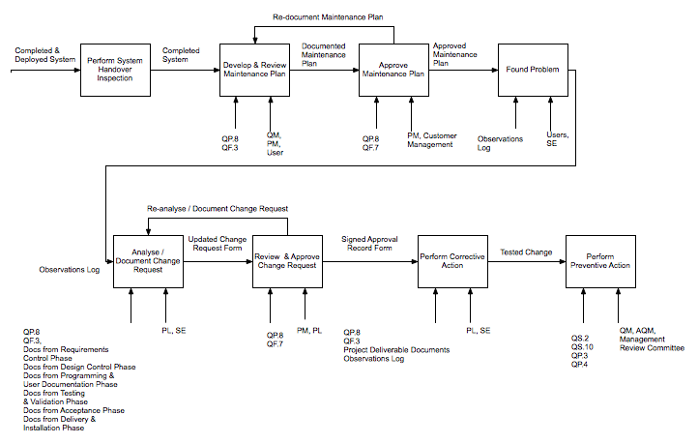

Purpose
- To ensure that system continues to support customers and meet customer’s requirements.

Process Flow
Steps | Tools/References
- Perform system handover inspection
- Ensure that all the configuration items in the operational baseline are available, updated and of the correct version. Verify the location of the configuration items.
- Review the development project schedule to ensure that outstanding activities and tasks would be followed up.

- Develop Maintenance Plan  - The scope of the maintenance plan includes the functions to be maintained, type of maintenance to be done and period of maintenance. If this cope has been defined during the development phases, it should be confirmed at the start of the maintenance.  - Use the operational baseline as a basis for defining or confirming the scope. Identify for each configuration item in the baseline and the party responsible for maintenance.  - The type of maintenance to be done consist of production support, corrective and preventive maintenance. Estimate the man-effort for each type of maintenance and the approved change requests. Estimate effort for evaluation and implementation of future change requests received in the period covered by the Maintenance Plan. Refer to a previous Maintenance Plan, if any, or Maintenance Plan of a similar application system.  - Priorities and schedule change requests and maintenance tasks. Estimate additional costs for the acquisition of any new hardware or software.  - Draft and review the Maintenance Plan with the User Representative before presenting to the management for approval. The purpose of this review is to assure the completeness and correctness of the Maintenance Plan. | Maintenance Plan Template
- Approve Maintenance Plan  - Obtain approval from the Project Manager and Customer Management for the Maintenance Plan.  - Use the Approval Record Form to formally document the approval and attach the completed form to the plan. | XPRESS/QMS/QF.8
- Log Issue / Problem  - This is an ongoing reactive but ad-hoc type of activity. It involves users detecting deficiencies in the system or wish to enhance the system.  - Users shall log down the errors or suggestions for enhancements into the Observations Log. | Observations Log
- Analyze / Document Change Request  - The maintenance team should perform analyses on the issues/problems logged by the users in the Observation Log.  - Document the analyses and findings of the defect or enhancement into the Change Request Form. | XPRESS/QMS/QP.8  XPRESS/QMS/QF.3
- Review and Approve Change Request  - The Project Manager or Project Lead is to perform review on the Change Request.  - Use the Approval Record Form to formally document the approval and attach the completed form to the Change Request. | XPRESS/QMS/QP.8  XPRESS/QMS/QF.7
- Perform Corrective Action  - Corrective action is performed to eliminate an existing error or problem detected in the application system.  - Problems may be resolved through temporary fixes to minimise downtime. Where such cases occur, permanent solutions should be planned for and implemented later.  - For all corrective activities, ensure that appropriate site problem management procedure is followed.  - Observations log should be analysed to determine the cause and then corrective action should be performed if any.  - Refer to the Observations logs to obtain information on resolution method for similar problems.  - Follow site procedures to obtain authorisation to transfer the affected application programs from production environment to a development environment for modification and to access production data for problem determination when needed.  - As part of the corrective action, validation activities should take place to demonstrate and document that the problems are resolved.  - Test thoroughly before implementing the solution to the production environment.  - Follow site procedures in obtaining proper authorization to transfer modified software into production environment.  - Update affected project deliverables.  - Monitor the production system closely after the changes have been implemented. | XPRESS/QMS/QP.8  Observations Log  Project Deliverables Documents
- Perform Preventive Action  - Preventive action is performed to prevent similar problems from re occurring in the future.  - Steps must be taken to learn from the problems and errors detected or reported and make appropriate improvements.  - Collect all application maintenance data by application system.  - Perform internal audit reviews by analyse the maintenance data and identify the problems. This is ensured that procedures and guidelines have been followed to rectify the issue. | XPRESS/QMS/QS.2  XPRESS/QMS/QS.10  XPRESS/QMS/QP.3 XPRESS/QMS/QP.4

Quality Records
- Maintenance Plan
- Maintenance Plan Approval Record Form Record
- Record of Maintenance Plan review
- Completed Change Request Records
- Change Request Approval Record Form Record
- QMS Documentation Record
- Internal Audit Reviews

QUALITY SYSTEM FOR SUPPORTING ACTIVITIES

APPENDIX A: CROSS-REFERENCES TO ISO STANDARDS

APPENDIX B: LIST OF PROCEDURES

APPENDIX C: LIST OF GUIDELINES

APPENDIX D: LIST OF FORMS

